AGENCY

Protected Utility

AGENCY - SOP - Deploy App For Apple Corporate Devices - Admin
 | 
Date 22 September 2020

Document Information

Document Acceptance for v1.0
Function | Date | Name | Position
Prepared: | 14-09-2020 | Collin McKeahnie | Consultant
Review | 21-09-2020 | Mathew Laurence-Rogers | Managing Consultant
Release | 22-09-2020 | Mathew Laurence-Rogers | Managing Consultant

Drafting and Release History
Version | Date | Author | Description
0.1 | 14-09-2020 | Collin McKeahnie | Initial Document
0.2 | 21-09-2020 | Mathew Laurence-Rogers | Review and update
1.0 | 22-09-2020 | Mathew Laurence-Rogers | Release

oobe contact details | oobe Pty Ltd
oobe contact details | | www.oobe.com.au  | GPO 111 Canberra City 2601  | ACN 123 977 846  | ABN 48 123 977 846

Contents
Deploy App for Apple Corporate Device 4
Introduction 4
Purpose 4
Audience 4
Pre-Requisites 4
Purchase VPP App License 5
Deploy App To Corporate Phone 8

Deploy App for Apple Corporate Device

Introduction
The AGENCY offer a fully managed corporate iPhone, for apps to be made available to the device and the user not be required to pay for the app they must be provisioned through the AGENCY Apple business manager portal.

Purpose
This document is to guide an admin through the process of purchasing one or many app licences from the App Store and then deploying those apps to an AGENCY corporate iPhone.

Audience
Administrators

Pre-Requisites
- Apple Business Manager account has been set up. The admin attempting the work has permission to access the portal.
- The admin conducting the work is approved to make purchases on behalf of the AGENCY.

Purchase VPP App License
Step | Instruction | Screen Shot
 | Log into the Apple Businesss Manager Account at https://business.apple.com  Username: applemobile@AGENCY.com.au  Password: Stored by AGENCY | 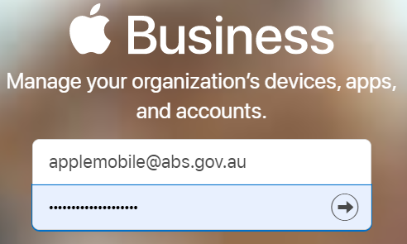
 | Select Apps and Books from the left menu | 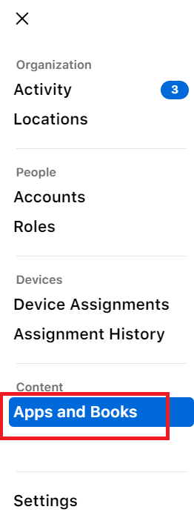
 | This will present the user with a portal to the Apple Apps Store.  The user can search for any app available in the store. | 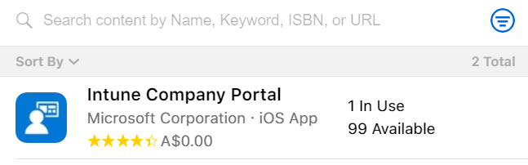
- The | The cost of each app is visible next to the rating. | 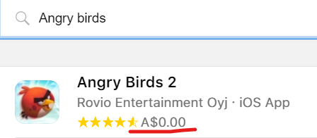
 | Once the user selects an app they are given the option to purchases licenses. To do so they need to select Australian Bureau of Statistics as the location to assign the licenses then choose the Quantity of licenses and finally press Get | 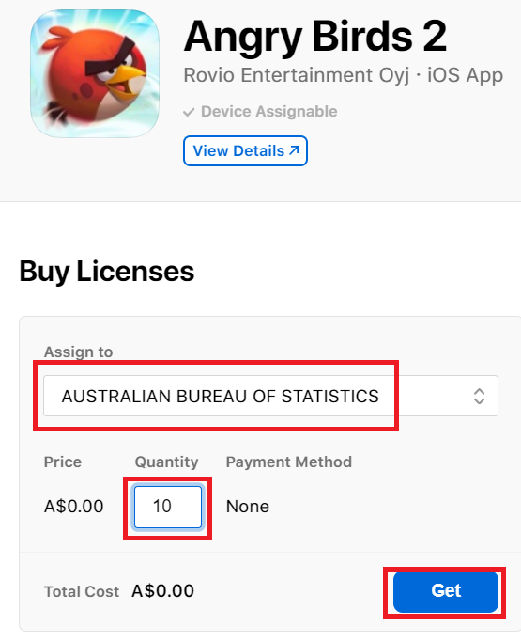
 | Licences can be viewed by going to settings at the bottom left | 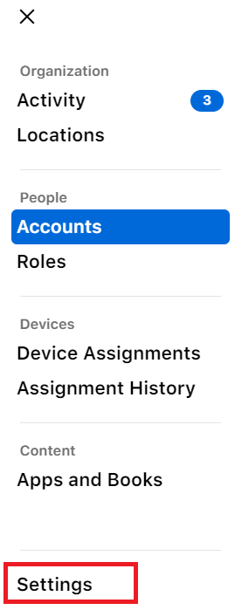
 | Selecting Apps and Books | 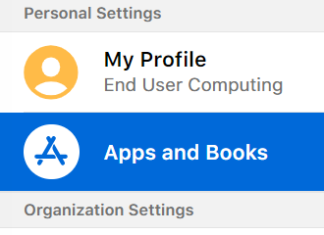
 | Under Purchases History select View | 

Deploy App To Corporate Phone
Step | Instruction | Screen Shot
 | Log into the Microsoft Endpoint Manager at https://endpoint.microsoft.com and select Tenant administration | 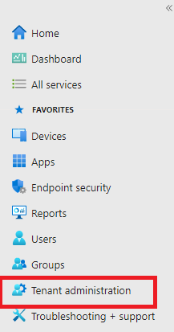
 | From the Tenant administration blade select Connectors and tokens | 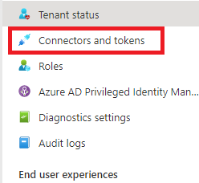
 | From the Connectors and tokens blade select Apple VPP Tokens | 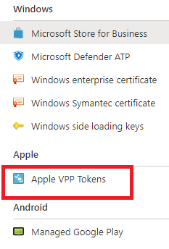
 | The AGENCY Apple VPP token will be visible here | 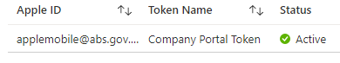
 | From the end of the row click the three dots and then press Sync  This will tell Intune to refresh the status of all the app licences with Apple. | 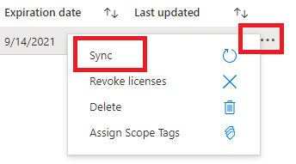
 | From the Endpoint Manger blade select Apps | 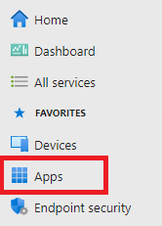
 | From the apps blade select iOS/iPadOS | 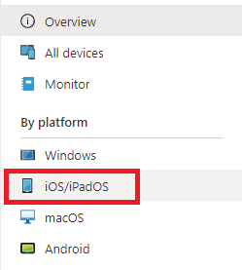
 | Locate and click the app you wish to deploy from the list. It will be the type iOS volume purchase program app | 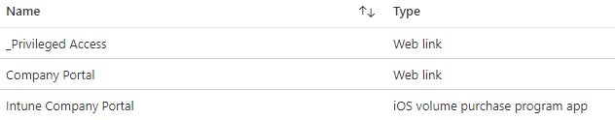
 | From the apps blade select Properties | 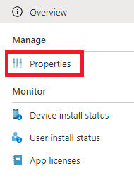
 | Scroll to Assignments and select Edit | 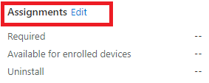
 | From here the admin can choose if they want the app to be Required – that would mean the app is force installed. Available – that would give the end users the option to install the app from within the Company Portal. Or to Uninstall – which would remove the app from the end-users phone.  Best practice is to select an AD group to have the app assigned to it and then manage the users who are a part of that group.  Creation and management of Azure Active Directory groups is outside the scope of this document. | 